**Business Vision for Aromy**

* Rui Qin 30874157
* Shangqian Du 31121632
* Pei Ern Cassandra Tong 31509509
* Eugene 27841898
* Daniel Phelan 29732638

**Report Date:** Version 2 15th August 2022

# Table of Contents

**Table of Contents** **2**

**1. Executive Overview** **3**

**2. The Organisation** **3**

2.1 Business Overview 3

2.3 Personas 5

**3. The Project** **6**

3.1 Project Timeline 6

3.2 Team Members 7

3.3 System Development Approach 8

3.4 Risks 8

**Client Sign-Off** **8**

# 

# 1. Executive Overview

This document is intended to provide an overview of the project that will be delivered to Aromy. It will present the business purposes of developing a secure website to promote the company’s products. It will provide an insight of the project team and how the team will develop the system. The development is based on the business requirements provided by you during our interview. The system will be conducted using the Agile framework where you will be able to review the developing system throughout the project. The first review will be given to you on 28/8/2022. You are able to provide any feedback on to the team and make changes to the requirements at any time.

Furthermore, the products control system that you have requested will be delivered to you on 21/9/2022 for the second review. Once the requirements are all fulfilled and the system is completed, it will be handed over to the company on 23/10/2022. If the end product satisfies your business requirements it will be presented live.

# 2. The Organisation

## 2.1 Business Overview

Aromy is an Australian supplier of aromy therapy based products and massage services for the aged care industry. It currently serves clients through a basic wordpress website with limited customer and administrator side functionality. As a result Aromy currently organises its inventory in an excel spreadsheet, so there's a lack of tracking of inventory and orders more broadly. The current system does not display much information about the products and services aromy offers. Alongside this, there is limited capacity to understand the needs and wants of the customer due to the limited functionality of the current website system.

2.2 System Requirements

**Priority 1**

* **Ability to organise the Inventory on real time**
  + Manage stock flow
    - Updating stock quantity (renewing stock)
    - SOH quantity
    - Redline/Reorder system when SOH is low
* **Ability to organise purchase orders**
  + Manage order flow
    - Updating stock quantity (deducting stock)
    - Updating order status (Processing | Shipping)
    - Sending information (emails) to customers
      * Invoice (order confirmation)
      * Inform order status through email

**Priority 2**

* **Product information**
  + View, Modify, Add
* **CRM to manage customer information (customers’ account) - able to view the list of customers and their details**
  + View, Modify, Add
* **Customer account**
  + Login/Logout
  + Purchase History
  + Shopping cart
  + Customer profile

**Priority 3**

* **Rewards/ credit points for purchases**
  + Reward system

## 2.3 Personas

Our team has created two user personas for what we envision as some of the various stakeholders in aromy. The first person we envision is one of the typical customers of Aromy, an individual that runs a massage shop and would like an easy catch-all way of purchasing aromatherapy products for their business. The second we envisage to be a typical employee involved in the warehouse and distribution side of Aromy, displaying a discontent with the old, antiquated systems and the excitement around the company to move on to more modern systems.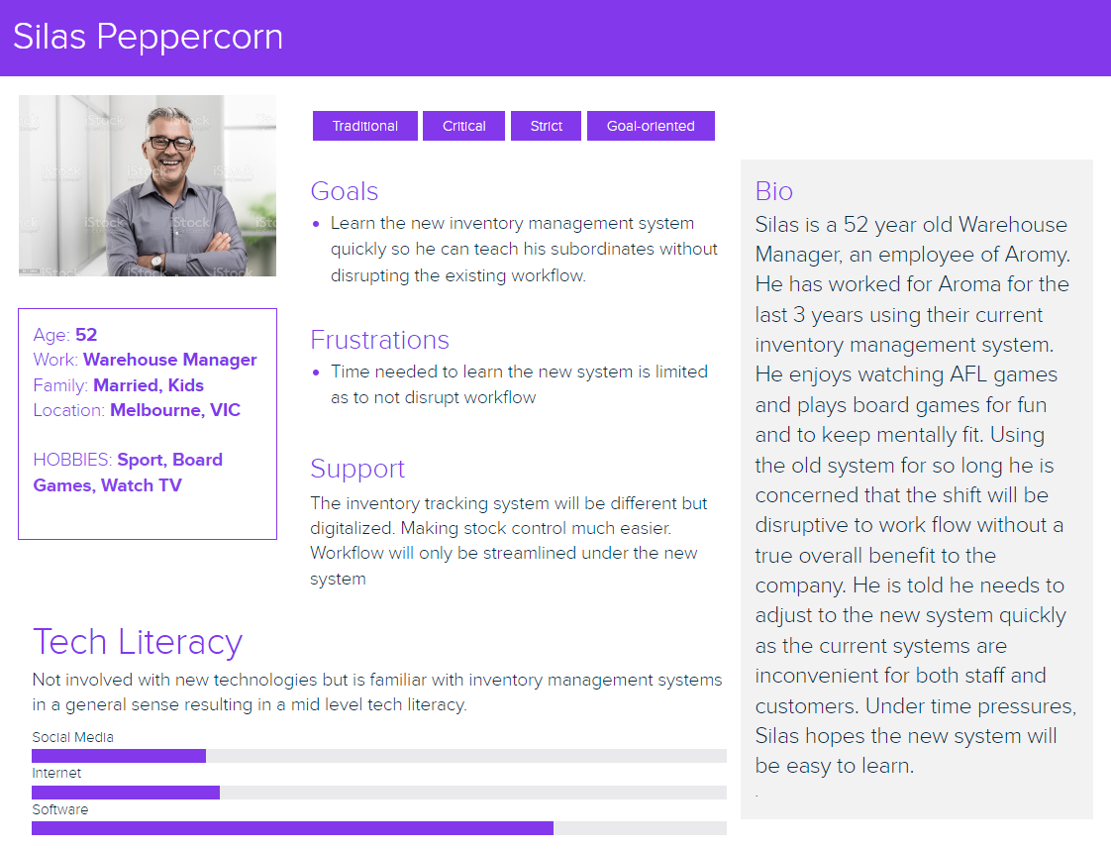

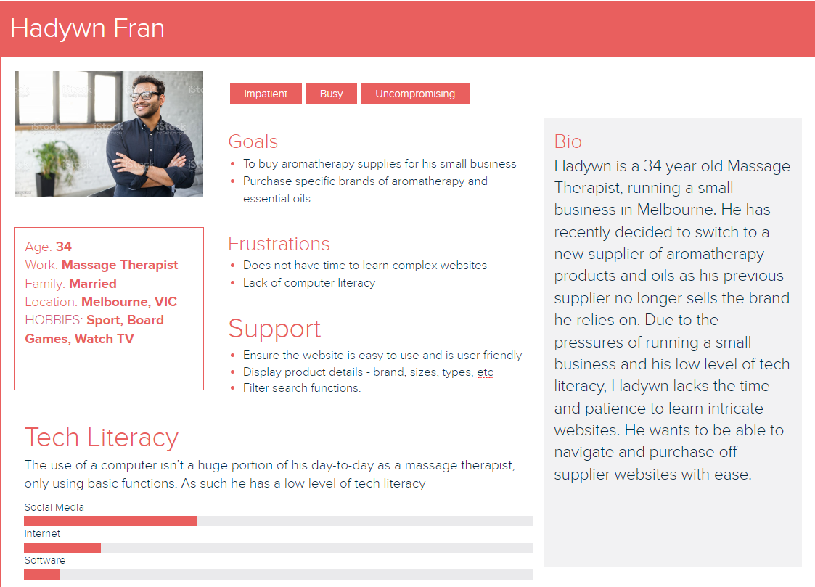

# 3. The Project

## 3.1 Project Timeline

| **Formal Meetings** | **Date** | **Involvement** |
| --- | --- | --- |
| Interview Product Owner | 8-08-22 | Client  Team |
| System Overview Report | 14-08-22 | Client  Team |
| Iteration 1 Report | 21-08-22 | Client |
| Iteration Handover for Acceptance Testing | 28-08-22 | Client |
| PIR | 02-09-22 | Client  Team |
| Iteration 2 Report | 11-09-22 | Client |
| Iteration Handover for Acceptance Testing | 21-09-22 | Client |
| PIR | 10-10-22 | Client  Team |
| Complete Handover of All Documentation and System | 23-10-22 | Client  Team |

## 3.2 Team Members

|  | Name: Cassandra Tong  Team Role: Client Liaison  Email: [pton0008@student.monash.edu](mailto:pton0008@student.monash.edu) |
| --- | --- |
|  | Name: Eugene Aquino  Team Role: Project Coordinator  Email: [eaaqu1@student.monash.edu](mailto:eaaqu1@student.monash.edu) |
|  | Name: Daniel  Team Role: Developer  Email: [dphe0001@student.monash.edu](mailto:dphe0001@student.monash.edu) |
|  | Name: Rui Qin(Allen)  Team Role: Developer  Email: [rqin0002@student.monash.edu](mailto:rqin0002@student.monash.edu) |
|  | Name: Shangqian Du (Frank)  Team Role: Developer  Email: [sduu0007@student.monash.edu](mailto:sduu0007@student.monash.edu) |

## 3.3 System Development Approach

The team will be conducting Agile methodology throughout the project development, in order for you to have greater understanding and involvement as the project progresses. The project will consist of multiple small iterations of well defined scope to be worked on. In this case, you will be frequently involved to review the complete work after an iteration, providing feedback to the development team before they move onto the next requirement. You are able to discuss with the team on any changes and priorities towards the business requirements at any time.

## 3.4 Risks

At this stage of the project, as the risks are quite minimal, our team has not identified any risks involved.

# 

# Client Sign-Off

Instructions:

1. Please review the enclosed material.
2. Please contact the client liaison with any questions or concerns that you may have during your review through email or phone call.
3. You can contact the client liaison to indicate changes at any time during the review.
4. Please send this sign-off document by 16th August 2022 to: (Cassandra, email: [pton0008@student.monash.edu](mailto:pton0008@student.monash.edu) ).

Approval Signature:

By signing this document, I acknowledge that team OneTen understands my business and requirements at this specific time. The team is delighted to work on any changes and modify the priorities on the business requirements, please contact the team directly.

Client: __________________________ Name and Date: ________________________

Team client liaison: __________________________ Name and Date: ______________